Sound / Audio in Multimedia Computing

Basic Sound Concepts, Types of Sound, Digitizing Sound, Audio Formats, Audio Tools, MIDI, Speech Generation, Speech Analysis, and Speech Transmission

Summary
Topic | Description
Basic Sound Concepts | Frequency, amplitude, wavelength, time period
Types of Sound | Analog, digital, audible, infrasonic, ultrasonic
Digitizing Sound | Sampling, quantization, encoding
Audio Formats | WAV, MP3, AAC, FLAC, OGG
Audio Tools | Recording, editing, mixing, analysis software
MIDI | Stores musical performance instructions rather than audio
Speech Generation | Converts text into speech (TTS)
Speech Analysis | Extracts information from speech for recognition and analysis
Speech Transmission | Captures, digitizes, compresses, transmits, and reconstructs speech

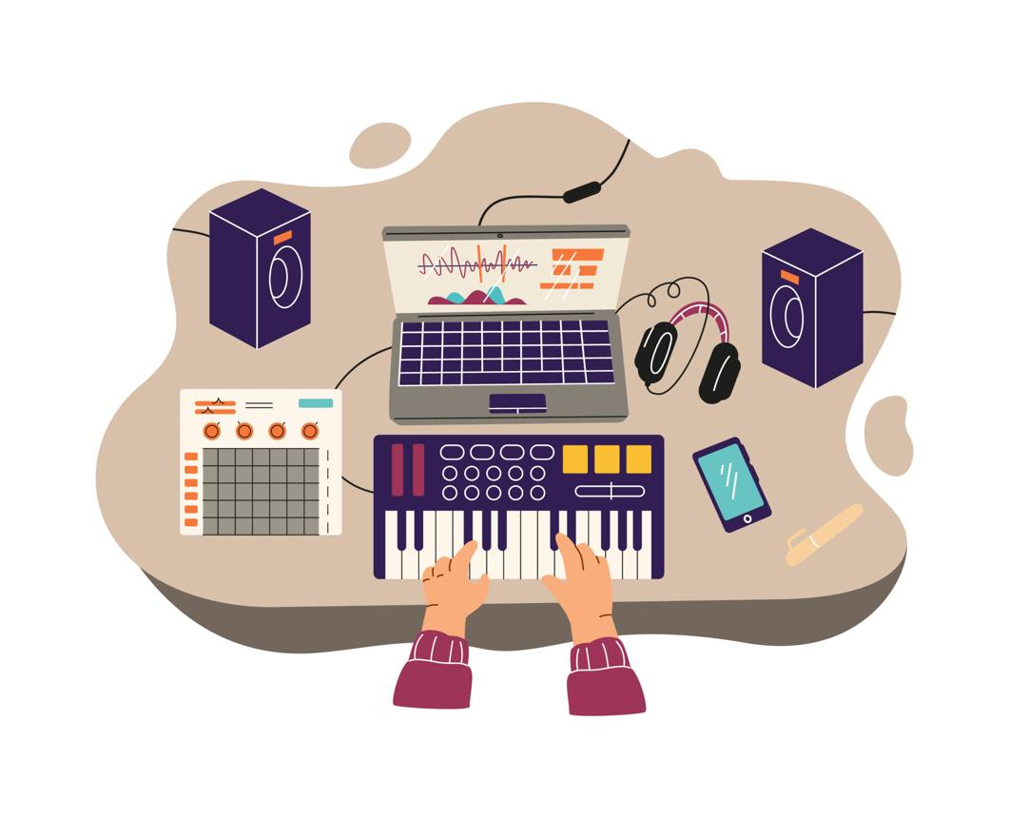
5

1. Introduction to Sound (Audio)
Sound is one of the most important components of multimedia. It enhances communication, entertainment, education, virtual reality, gaming, and human-computer interaction.
Without audio, multimedia applications become less interactive and engaging.

Definition
Sound is a form of mechanical energy produced by vibrating objects that travels through a medium (such as air, water, or solids) in the form of longitudinal waves and is perceived by the human ear.

Examples
- Human speech
- Music
- Animal sounds
- Vehicle horns
- Rainfall
- Musical instruments

Characteristics of Sound
Every sound has four important characteristics.

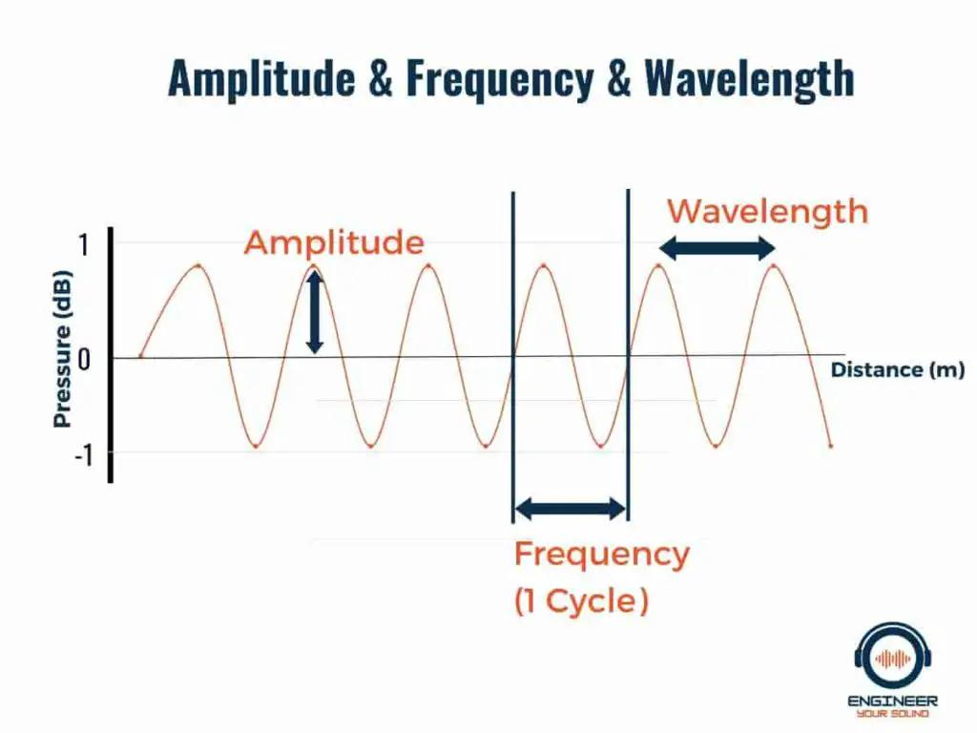

Wavelength Comparison
Wavelength | Frequency | Examples
Long | Low | Bass sounds, earthquakes
Medium | Medium | Human speech
Short | High | Ultrasound, bats

Relationship Between Frequency, Amplitude, and Wavelength
Property | Determines | Unit | Effect When Increased
Frequency | Pitch | Hertz (Hz) | Higher pitch
Amplitude | Loudness | Decibel (dB) | Louder sound
Wavelength | Distance between wave peaks | Meter (m) | Longer wavelength corresponds to lower frequency (for a constant wave speed)

Comparison of Frequency, Amplitude, and Wavelength
Feature | Frequency | Amplitude | Wavelength
Definition | Number of vibrations per second | Maximum displacement of the wave | Distance between two consecutive crests or compressions
Symbol | f | A | λ
Unit | Hertz (Hz) | Decibel (dB) for sound level (wave amplitude itself is a displacement) | Meter (m)
Determines | Pitch | Loudness | Spatial length of one wave cycle
High Value Means | High pitch | Loud sound | Long wavelength if wave speed changes, but at constant speed high frequency actually means short wavelength

1. Frequency (Pitch)
Frequency indicates the number of vibrations occurring in one second.

Unit
Hertz (Hz)

Formula
f=1/T
Where:
- f = Frequency (Hz)
- T = Time period (seconds)

Example
A sound vibrating 440 times per second has a frequency of:
440 Hz
This corresponds to the musical note A4, commonly used for tuning instruments.

Human Hearing Range
20 Hz – 20,000 Hz (20 kHz)

2. Amplitude (Loudness)
Amplitude represents the maximum displacement of the sound wave.
Higher amplitude produces louder sound.

Unit
Decibel (dB)

Examples
Sound | Approximate Level
Whisper | 30 dB
Normal conversation | 60 dB
Busy traffic | 85 dB
Rock concert | 110 dB
Jet engine (close range) | 130–140 dB

3. Time Period
Time required to complete one vibration.
T=1/f

4. Wavelength
Distance between two consecutive wave peaks.
Formula:
λ=v/f
Where
- λ = Wavelength
- v = Speed of sound
- f = Frequency
Speed of sound in air (approximately):
343 m/s
at 20°C.

Basic Sound Wave
Amplitude
▲
│
/\ /\
/ \ / \
______/____\____/____\______ Time
Peak Peak
Distance between two peaks = Wavelength (λ)

2. Types of Sound

A. Analog Sound
Analog sound is continuous.
Examples
- Human voice
- Guitar sound
- Piano
- Radio broadcasting
Advantages
- Natural representation
Disadvantages
- Easily affected by noise.

B. Digital Sound
Digital sound is represented as binary numbers.
Examples
- MP3
- WAV
- Digital recording
- CDs
Advantages
- Easy storage
- Noise resistant
- Easy editing

C. Audible Sound
Frequency:
20 Hz–20 kHz
Humans can hear this range.
Examples
- Speech
- Music
- Animal sounds

D. Infrasonic Sound
Frequency:
Below 20 Hz
Examples
- Earthquakes
- Volcanoes
- Elephants (low-frequency communication)

E. Ultrasonic Sound
Frequency:
Above 20 kHz
Examples
- Medical ultrasound imaging
- SONAR
- Bats
- Dolphins

Summary of Sound Types
Type | Frequency | Examples
Infrasonic | <20 Hz | Earthquakes, elephant communication
Audible | 20 Hz–20 kHz | Speech, music
Ultrasonic | >20 kHz | Ultrasound, bats, SONAR

3. Digitizing Sound
Digitization converts analog sound into digital data.
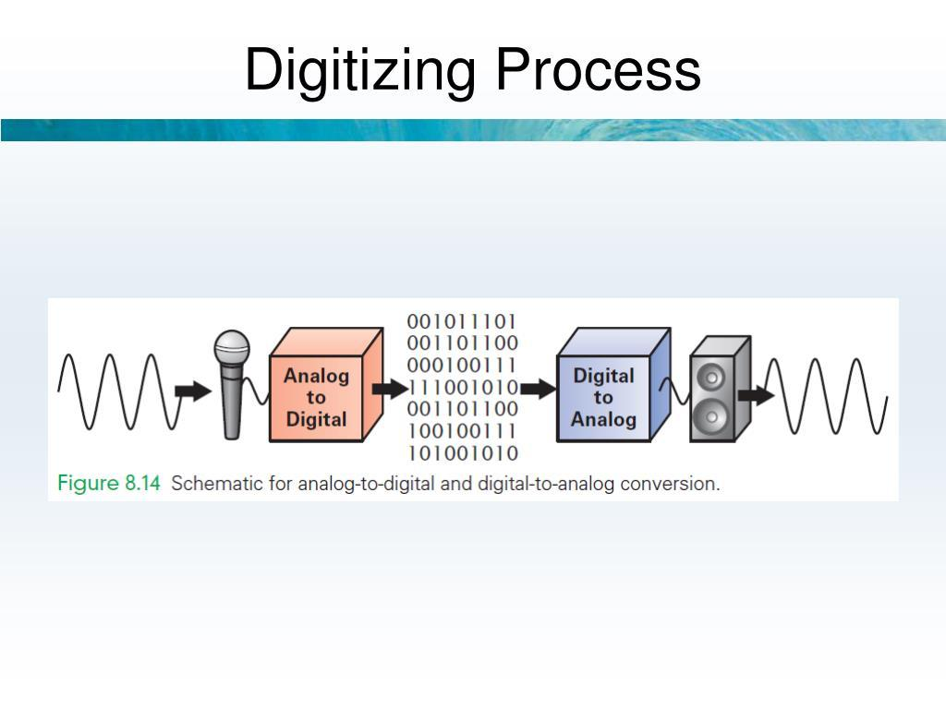

5

Introduction
Digitizing Sound is the process of converting continuous analog sound waves into digital data (binary numbers) so that computers can store, process, edit, and transmit audio.
This process is also known as Analog-to-Digital Conversion (ADC) and is a fundamental concept in Multimedia Computing, Digital Signal Processing (DSP), Computer Networks, and Audio Engineering.

Digitizing Sound Process (Analog-to-Digital Conversion)
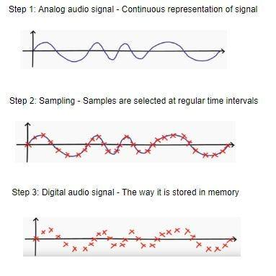
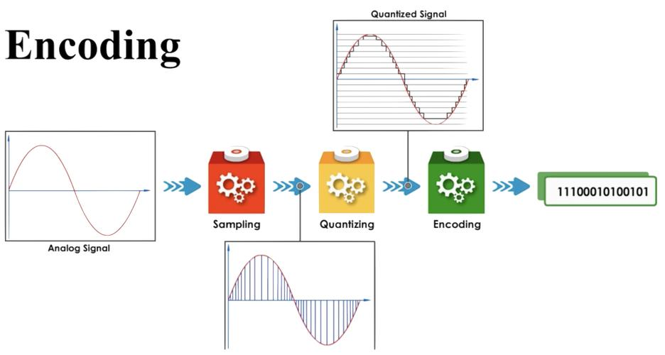

Definition
Digitizing Sound is the process of converting analog audio signals into digital form by performing sound acquisition, sampling, quantization, encoding, compression (optional), storage, and playback.
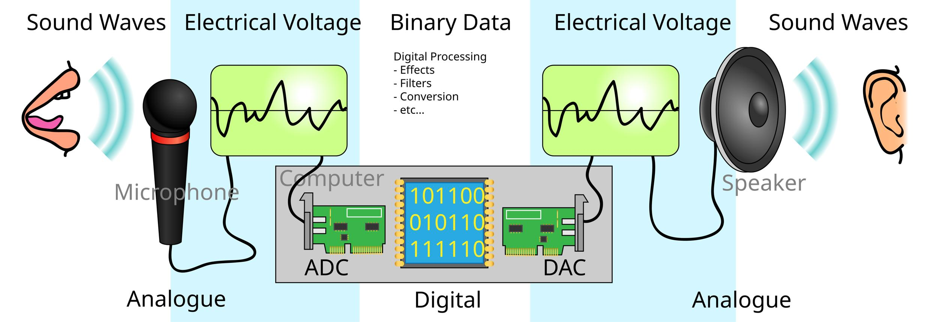

Why Do We Need Digitizing Sound?
Analog sound cannot be directly processed by a computer because computers understand only binary digits (0 and 1).
Digitization enables computers to:
- Store audio files.
- Edit and enhance sound.
- Transmit audio over the Internet.
- Stream music and podcasts.
- Recognize speech using Artificial Intelligence.
- Compress audio efficiently.

Real-Life Examples
- Recording voice using a smartphone.
- Making a voice call over the Internet.
- Recording songs in a studio.
- Uploading audio to cloud storage.
- Voice assistants such as Siri, Google Assistant, and Alexa.

Complete Digitizing Sound Process
Analog Sound Source
│
▼
Microphone (Sound Capture)
│
▼
Analog Electrical Signal
│
▼
Pre-amplification & Filtering
│
▼
Sampling
│
▼
Quantization
│
▼
Binary Encoding
│
▼
Compression (Optional)
│
▼
Digital Audio File
│
▼
Storage / Transmission
│
▼
Playback (Digital-to-Analog Conversion)
The digitization process consists of several important stages.

Summary of Digitizing Sound Process
Stage | Description
1 | Sound Generation – Vibrations create sound waves
2 | Sound Capture – Microphone converts sound into an analog electrical signal
3 | Signal Conditioning – Amplify and filter the signal
4 | Sampling – Measure amplitude at regular intervals
5 | Quantization – Convert samples into discrete levels
6 | Encoding – Represent samples in binary form
7 | Compression (Optional) – Reduce file size
8 | Storage – Save as a digital audio file
9 | Transmission – Send through a communication network
10 | Playback – Convert digital data back to analog using a DAC and reproduce it through speakers

Stage 1: Sound Generation

Definition
Sound is produced when an object vibrates.
Examples include:
- Human voice
- Guitar strings
- Piano
- Drum
- Car horn
These vibrations create pressure waves that travel through air.

Fact
Sound cannot travel in a vacuum because it requires a material medium (air, water, or solids).

Stage 2: Sound Capture (Microphone)

Definition
A microphone captures sound waves and converts them into an analog electrical signal.

Working Principle
Voice
↓
Microphone Diaphragm Vibrates
↓
Electrical Signal Produced
The analog electrical signal has the same shape as the original sound wave.

Types of Microphones
- Dynamic Microphone
- Condenser Microphone
- Ribbon Microphone
- Lavalier (Lapel) Microphone
- USB Microphone

Stage 3: Signal Conditioning (Pre-amplification and Filtering)

Definition
Before digitization, the analog signal is prepared for accurate conversion.

Main Operations

A. Amplification
Weak microphone signals are amplified.

B. Noise Filtering
Unwanted electrical noise is reduced.

C. Anti-Aliasing Filter
A low-pass filter removes frequencies above half the sampling rate (the Nyquist frequency) to reduce aliasing, where high-frequency components could otherwise appear as incorrect lower frequencies after sampling.

Stage 4: Sampling

Definition
Sampling measures the amplitude of the analog signal at regular time intervals.
Instead of recording a continuous waveform, the system stores many discrete samples every second.

Sampling Frequency
Number of samples collected every second.
Unit:
Hertz (Hz)

Mathematical Formula
Sampling Rate=Samples/SecondSampling\ Rate = Samples/SecondSampling Rate=Samples/Second

Example
Sampling Rate:
44,100 Hz
This means
44,10044,10044,100
samples are taken every second.

Common Sampling Rates
Sampling Rate | Applications
8 kHz | Telephone systems
16 kHz | Voice recognition
22.05 kHz | Voice recording
44.1 kHz | Audio CD
48 kHz | Video production
96 kHz | Professional recording
192 kHz | Studio mastering

Nyquist Sampling Theorem
To accurately reproduce a signal,
Sampling Rate≥2×Highest FrequencySampling\ Rate \ge 2 \times Highest\ FrequencySampling Rate≥2×Highest Frequency

Example
Human hearing range:
20 kHz
Minimum sampling rate:
2×20=40kHz2 \times 20 = 40kHz2×20=40kHz
Therefore,
44.1 kHz is sufficient for CD-quality audio.

Illustration
Continuous Wave

~~~~~~~~~~~~~~~
↓
Sampling
• • • • • •
Each dot represents one sample.

Stage 5: Quantization

Definition
After sampling, each sample is assigned the nearest available amplitude level.

Introduction
Quantization is the second major step in the digitization of sound, following sampling. During quantization, each sampled amplitude of an analog signal is assigned to the nearest available digital value (quantization level). Since computers can only represent a finite number of values, continuous amplitudes must be approximated.
Without quantization, computers would not be able to store analog sound as digital data.

Definition
Quantization is the process of converting the continuous amplitude values obtained during sampling into a finite set of discrete levels that can be represented digitally.

Applications of Quantization
- Digital music recording
- Audio CDs
- Mobile phones
- Voice over IP (VoIP)
- Speech recognition
- Hearing aids
- Medical audio systems
- Multimedia streaming

Advantages
- Converts analog amplitudes into digital values.
- Enables digital storage and processing.
- Supports efficient transmission.
- Improves compatibility with computer systems.
- Higher bit depths provide more accurate sound representation.
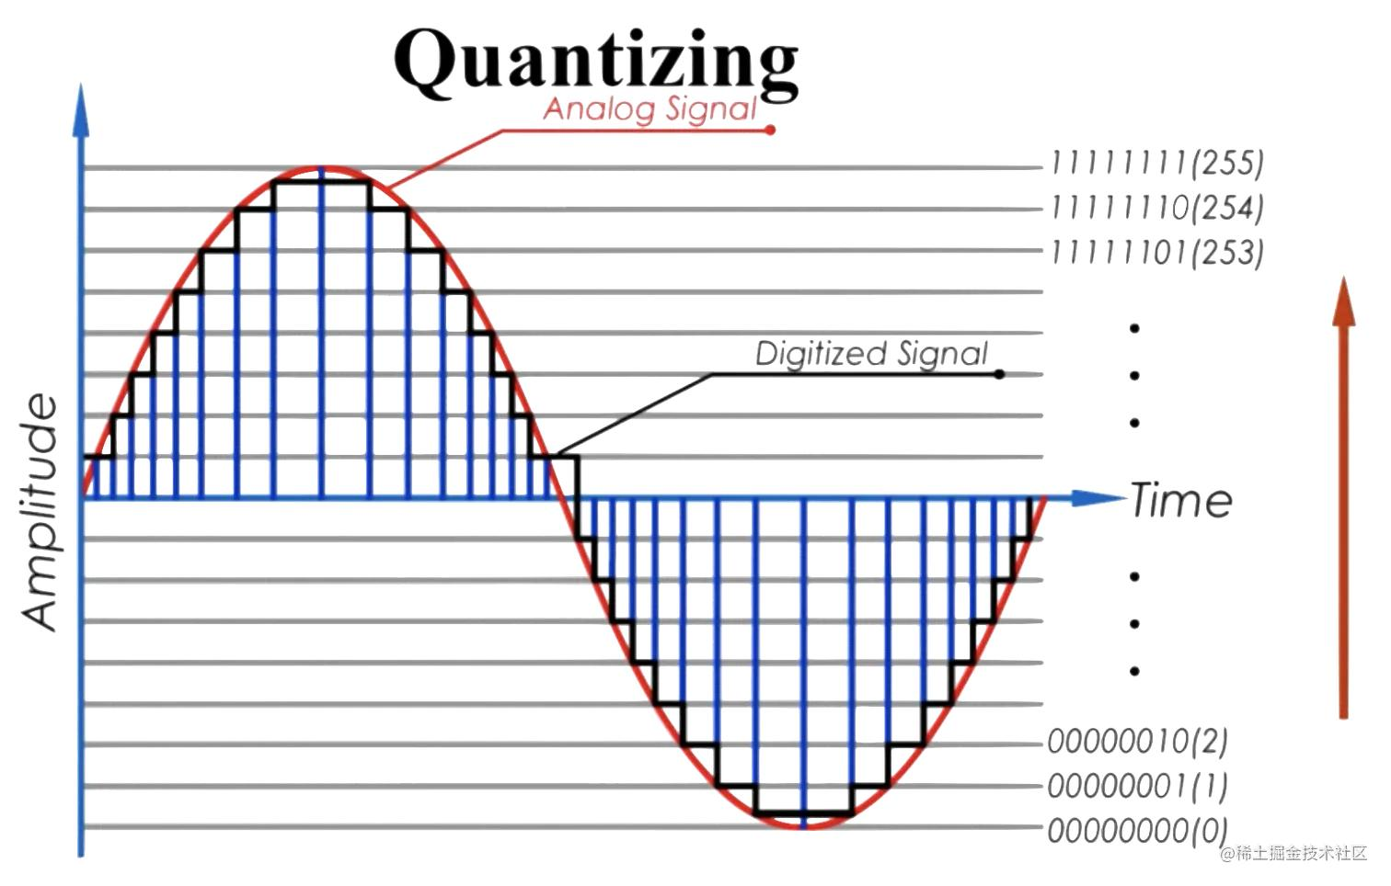

Position of Quantization in Audio Digitization
Analog Sound
│
▼
Microphone
│
▼
Sampling
│
▼
Quantization
│
▼
Encoding
│
▼
Digital Audio File

Why is Quantization Necessary?
During sampling, the analog signal is measured at regular intervals.
Example sampled values:
0.12
0.57
1.43
2.98
3.67
These values are continuous and may contain many decimal places.
However, computers can only store a limited number of binary values. Therefore, each sampled value is approximated to the nearest available quantization level.

Example
Sampled value:
3.67
Nearest available level:
4
The computer stores 4 instead of 3.67.

Continuous vs. Discrete Values

Before Quantization (Continuous)
0.12
0.35
1.58
2.76
3.91
4.42
Infinite possible values exist between any two amplitudes.

After Quantization (Discrete)
0
0
2
3
4
4
Only fixed amplitude levels are allowed.

Since computers cannot store infinitely many amplitude values, they approximate each sample.

Bit Depth
Bit depth determines how many amplitude levels are available.
Formula
Levels=2nLevels = 2^nLevels=2n
Where
n = Bit Depth

Examples
Bit Depth | Levels
8-bit | 256
16-bit | 65,536
24-bit | 16,777,216
32-bit | 4,294,967,296 (integer representation)
Higher bit depth generally provides better dynamic range and less quantization error.

Quantization Illustration
Original Value = 7.84
↓
Nearest Level
8
This approximation introduces quantization error, which is usually reduced by using higher bit depths.

Stage 6: Encoding

Definition
Each quantized sample is converted into binary numbers.
Example
Amplitude:
145
Binary:
10010001
The computer stores these binary values.

Stage 7: Compression (Optional)

Definition
Compression reduces the size of the digital audio file.

Lossless Compression
Original audio is perfectly reconstructed.
Examples:
- FLAC
- ALAC
Applications
- Music archives
- Professional editing

Lossy Compression
Some audio information is discarded to reduce file size.
Examples:
- MP3
- AAC
- OGG Vorbis
Applications
- Music streaming
- Podcasts
- Mobile devices

Stage 8: Storage
Digital audio is stored in files.
Examples
- WAV
- MP3
- AAC
- FLAC
- OGG
Storage media
- Hard Disk
- SSD
- USB Flash Drive
- CD/DVD
- Cloud Storage

Stage 9: Transmission
The audio file may be transmitted through:
- Internet
- Wi-Fi
- Bluetooth
- Mobile Network
- Optical Fiber
Examples
- Voice calls
- Music streaming
- Online meetings
- Podcasts

Stage 10: Playback (Digital-to-Analog Conversion)

Definition
During playback, the digital samples are converted back into an analog electrical signal by a Digital-to-Analog Converter (DAC).

Process
Digital File
↓
DAC
↓
Amplifier
↓
Speaker
↓
Sound Heard
The speaker converts the electrical signal into sound waves that the listener hears.

Mathematical Example
Suppose
Sampling Rate:
44,100 Hz
Bit Depth:
16 bits
Stereo Audio
Number of Channels:
2
Duration:
60 seconds

Calculate Storage Requirement
Size=Sampling Rate×Bit Depth×Channels×TimeSize =44100×16×2×60=44100\times16\times2\times60=44100×16×2×60 =84,672,000 bits=84,672,000\text{ bits}=84,672,000 bits
Convert into bytes
=84,672,0008=\frac{84,672,000}{8}=884,672,000​ =10,584,000 bytes=10,584,000\text{ bytes}=10,584,000 bytes
≈ 10.1 MB (using 1 MB = 1,048,576 bytes, the value is approximately 10.1 MiB).

Real-Life Example: Recording a Song
Suppose a singer records a song.

Step 1
Singer sings.
↓

Step 2
Microphone captures sound.
↓

Step 3
Audio interface amplifies and filters the signal.
↓

Step 4
ADC samples the waveform (e.g., 44.1 kHz).
↓

Step 5
Samples are quantized (e.g., 24-bit).
↓

Step 6
Samples are encoded into binary.
↓

Step 7
The recording is saved as WAV.
↓

Step 8
The final version is compressed to MP3 or AAC for online streaming.

Advantages of Digitizing Sound
- High audio quality.
- Easy editing and processing.
- Efficient storage and compression.
- Reliable transmission.
- Supports AI-based speech recognition.
- Minimal quality loss when copying digital files.

Limitations
- Higher sampling rates and bit depths require more storage.
- Lossy compression may reduce audio quality.
- Background noise affects recordings.
- Real-time processing requires sufficient computing resources.

Summary of Digitizing Sound Process
Stage | Description
1 | Sound Generation – Vibrations create sound waves
2 | Sound Capture – Microphone converts sound into an analog electrical signal
3 | Signal Conditioning – Amplify and filter the signal
4 | Sampling – Measure amplitude at regular intervals
5 | Quantization – Convert samples into discrete levels
6 | Encoding – Represent samples in binary form
7 | Compression (Optional) – Reduce file size
8 | Storage – Save as a digital audio file
9 | Transmission – Send through a communication network
10 | Playback – Convert digital data back to analog using a DAC and reproduce it through speakers

Conclusion
The Digitizing Sound Process converts continuous analog sound into digital audio that computers can store, process, transmit, and reproduce. It involves sound capture, signal conditioning, sampling, quantization, encoding, optional compression, storage, transmission, and playback. High-quality digital audio depends primarily on appropriate sampling rates, sufficient bit depth, and suitable compression methods, making this process essential for modern multimedia systems, digital music, speech recognition, telecommunications, and audio streaming.

Digitizing Process
Analog Sound
│
▼
Microphone
│
▼
Sampling
│
▼
Quantization
│
▼
Encoding
│
▼
Digital Audio File

Step 1: Sampling
The analog signal is measured at regular intervals.

Sampling Rate
Number of samples collected per second.

Unit
Samples/second (Hz)
Common Sampling Rates
Sampling Rate | Applications
8 kHz | Telephone
22.05 kHz | Voice recording
44.1 kHz | Audio CD
48 kHz | Video production
96 kHz | Professional recording
192 kHz | Studio mastering

Nyquist Theorem
To reproduce a signal accurately,
Sampling Rate≥2×Highest FrequencySampling\ Rate \ge 2 \times Highest\ FrequencySampling Rate≥2×Highest Frequency
Example
Human hearing = 20 kHz
Minimum sampling rate:
2×20=40kHz
This is why 44.1 kHz is sufficient for CD-quality audio.

Step 2: Quantization
Each sampled value is assigned to the nearest discrete amplitude level.
Bit depth determines the number of levels.
Examples
Bit Depth | Levels
8-bit | 256
16-bit | 65,536
24-bit | 16,777,216
32-bit (floating point in many systems) | Very high dynamic range for processing
Higher bit depth generally provides greater dynamic range and lower quantization noise.

Step 3: Encoding
Quantized values are stored as binary numbers.
Example
10100111
01101001
11001010

4. Audio Formats
Audio formats store digital sound.

A. WAV (Waveform Audio File Format)
Characteristics
- Uncompressed
- High quality
- Large file size
Applications
- Studio recording
- Audio editing

B. MP3 (MPEG Audio Layer III)
Characteristics
- Lossy compression
- Small file size
Applications
- Music streaming
- Portable music players

C. AAC (Advanced Audio Coding)
Characteristics
- Better compression efficiency than MP3 at similar bitrates
Applications
- Streaming services
- Mobile devices

D. FLAC (Free Lossless Audio Codec)
Characteristics
- Lossless compression
- High quality
- Smaller than WAV
Applications
- Music archiving
- Audiophile collections

E. OGG Vorbis
Characteristics
- Open-source
- Good quality
- Efficient compression
Applications
- Games
- Streaming

Audio Format Comparison
Format | Compression | Quality | File Size
WAV | None | Excellent | Very Large
MP3 | Lossy | Good | Small
AAC | Lossy | Very Good | Small
FLAC | Lossless | Excellent | Medium
OGG | Lossy | Good | Small

5. Audio Tools
Audio tools are software applications used to create, edit, record, mix, and analyze audio.

Examples
- Audacity
- Adobe Audition
- GarageBand
- Reaper
- Ocenaudio
- Logic Pro
- Pro Tools

Functions
- Recording
- Editing
- Noise reduction
- Mixing
- Equalization
- Audio effects
- Format conversion
- Podcast production

6. MIDI (Musical Instrument Digital Interface)
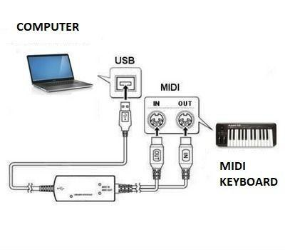
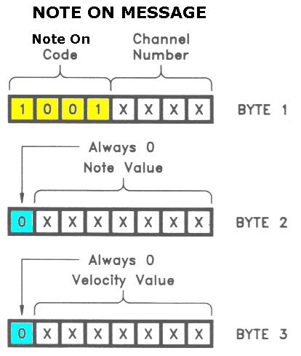
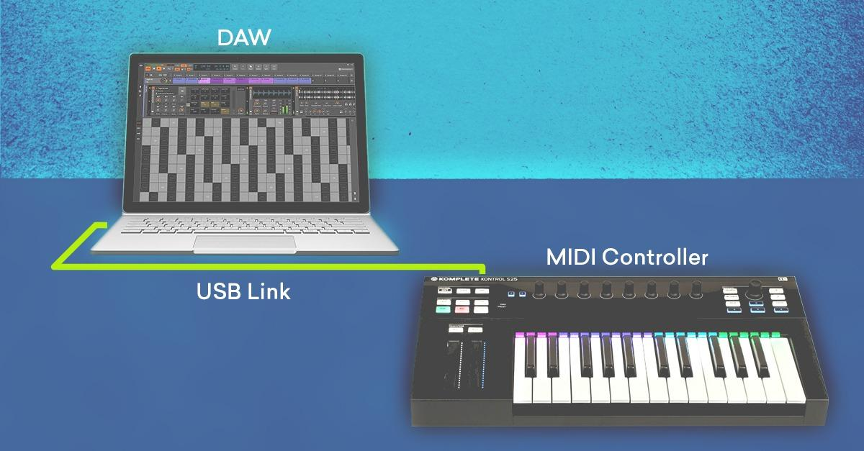
6

Definition
MIDI (Musical Instrument Digital Interface) is a communication standard that allows electronic musical instruments, computers, and other devices to exchange musical performance information.
Unlike MP3 or WAV, MIDI stores performance instructions, not recorded sound.

Example
Instead of storing:
"A piano sound"
MIDI stores:
- Piano instrument
- Note C
- Volume
- Duration
- Tempo
The receiving device generates the sound.

Components
- MIDI Keyboard
- MIDI Controller
- Computer
- MIDI Interface
- Synthesizer

MIDI Messages
Examples
- Note ON
- Note OFF
- Pitch Bend
- Program Change
- Control Change
- Velocity

Advantages
- Very small file size
- Easy editing
- Instrument changes without rerecording
- Ideal for music composition

Limitations
- Depends on the synthesizer or sound library for playback quality.
- Not suitable for recording human speech.

7. Speech Generation

Definition
Speech generation is the process of converting text into spoken language.
Also known as
Text-to-Speech (TTS)

Introduction
Speech Generation is the process of converting written text into natural, understandable speech using computer technology. It enables computers and smart devices to "speak" by transforming text into audio signals.
Speech generation is also called Text-to-Speech (TTS) or Speech Synthesis.
It is a fundamental technology in Multimedia Computing, Artificial Intelligence (AI), Natural Language Processing (NLP), Human-Computer Interaction (HCI), and Assistive Technology.

Definition
Speech Generation (Text-to-Speech) is the process of automatically converting digital text into intelligible and natural-sounding speech using linguistic analysis, pronunciation modeling, prosody generation, and speech synthesis techniques.

Objectives of Speech Generation
The primary goals are to:
- Convert text into spoken language.
- Produce natural and intelligible speech.
- Improve accessibility for visually impaired users.
- Enable voice assistants and conversational systems.
- Support multilingual communication.
- Provide audio content for education and entertainment.

Speech Generation Process
Input Text
│
▼
Text Analysis
│
▼
Phoneme Generation
│
▼
Prosody Generation
│
▼
Speech Synthesis
│
▼
Audio Output

Speech Generation Process (Text-to-Speech – TTS)
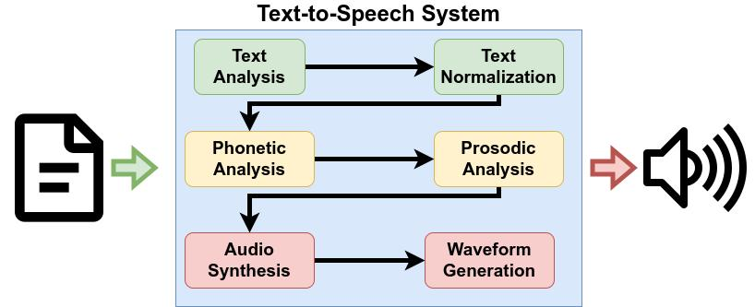
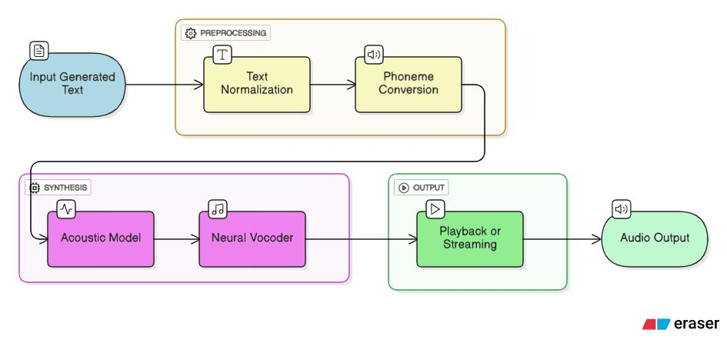
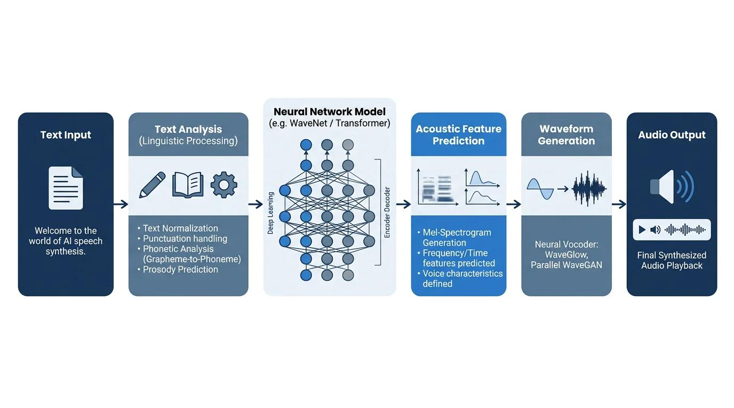

Complete Speech Generation Process
Input Text
│
▼
Text Preprocessing
│
▼
Linguistic Analysis
│
▼
Phoneme Generation
│
▼
Prosody Generation
│
▼
Speech Synthesis
│
▼
Digital Audio Signal
│
▼
Digital-to-Analog Conversion
│
▼
Speaker / Headphones
│
▼
Human Listener
The speech generation process consists of several important stages.

Summary of Speech Generation Process
Stage | Description
1 | Text Input – Receive digital text from the user or application
2 | Text Preprocessing – Normalize numbers, abbreviations, dates, symbols, and punctuation
3 | Linguistic Analysis – Perform tokenization, grammatical, syntactic, and semantic analysis
4 | Phoneme Generation – Convert words into pronunciation units (phonemes)
5 | Prosody Generation – Add pitch, stress, rhythm, pauses, and intonation
6 | Speech Synthesis – Generate a speech waveform using synthesis techniques
7 | Digital Audio Generation – Produce digital audio samples
8 | Digital-to-Analog Conversion – Convert digital samples into an analog signal
9 | Speaker Output – Play the speech through speakers or headphones

Stage 1: Text Input

Definition
The process begins with digital text entered by a user or obtained from a document, webpage, or application.

Examples
Welcome to Multimedia Computing.
or
Today's weather is sunny.
The system first receives this text as input.

Stage 2: Text Preprocessing (Normalization)

Definition
Raw text often contains abbreviations, numbers, dates, symbols, and punctuation that cannot be spoken directly. Text preprocessing converts them into a form suitable for speech.

Main Activities

A. Remove unnecessary symbols
Example
Hello!!!
↓
Hello

B. Expand abbreviations
Abbreviation | Spoken Form
Dr. | Doctor
Mr. | Mister
Prof. | Professor
etc. | et cetera
Example
Dr. Sharma
↓
Doctor Sharma

C. Convert numbers
Example
2026
↓
Two thousand twenty-six

D. Convert dates
Example
08/07/2026
↓
Eighth of July, two thousand twenty-six

E. Convert currency
Example
Rs. 500
↓
Five hundred rupees

F. Handle punctuation
Punctuation influences pauses and intonation.
Example
Hello, everyone.
The comma creates a short pause, while the period marks the end of the sentence.

Stage 3: Linguistic Analysis

Definition
The system analyzes the grammatical and linguistic structure of the sentence.

Main Activities

A. Tokenization
The sentence is divided into words and punctuation.
Example
Welcome to Multimedia Computing.
↓
Welcome
to
Multimedia
Computing

B. Part-of-Speech (POS) Tagging
Each word is identified according to its grammatical role.
Example
Word | POS
Welcome | Verb
Multimedia | Adjective (in this context)
Computing | Noun

C. Syntactic Analysis
The sentence structure is analyzed to understand relationships between words.

D. Semantic Analysis
The system interprets the meaning of the sentence to improve pronunciation and intonation.

Stage 4: Phoneme Generation

Definition
A phoneme is the smallest unit of sound that distinguishes one word from another in a language.
The system converts words into phoneme sequences using pronunciation dictionaries and language rules.

Example
Word
Computer
↓
Approximate phonemes
/k ə m ˈp juː t ər/
Another example
Hello
↓
/h ə ˈl oʊ/

Grapheme-to-Phoneme (G2P) Conversion
Unknown words or names are converted into phonemes using pronunciation rules.
Example
ChatGPT
↓
Pronunciation is generated according to language-specific rules.

Stage 5: Prosody Generation

Definition
Prosody refers to the rhythm, stress, pitch, speaking rate, and pauses in speech.
Without prosody, speech sounds robotic.

Components

A. Pitch
Determines whether the voice sounds high or low.

B. Stress
Certain syllables are emphasized.
Example
PREsent (noun)
preSENT (verb)

C. Intonation
Pitch changes across a sentence.
Example
Statement
You are coming.
Question
Are you coming?
The question usually ends with a rising intonation.

D. Speaking Rate
Controls how fast or slowly the speech is produced.

E. Pause Generation
The system inserts pauses after commas, periods, and other punctuation marks.

Stage 6: Speech Synthesis

Definition
Speech synthesis converts phonemes and prosody into a digital speech waveform.

Overall Speech Synthesis Process
Text Input
│
▼
Text Normalization
│
▼
Linguistic Analysis
│
▼
Phoneme Conversion
│
▼
Prosody Generation
│
▼
Speech Synthesis Engine
│
▼
Audio Waveform
│
▼
Speaker Output

Applications of Speech Synthesis
- Virtual assistants (e.g., Siri, Google Assistant, Alexa)
- GPS navigation systems
- Screen readers for visually impaired users
- Audiobook generation
- Customer service chatbots
- Language learning applications
- Smart home devices
- Automated announcements in transportation systems

Stage 7: Digital Audio Generation
The synthesized speech is stored as digital audio samples.
Typical properties
Property | Example
Sampling Rate | 16 kHz, 22.05 kHz, 44.1 kHz
Bit Depth | 16-bit
Channels | Mono or Stereo
The result is a digital audio stream.

Stage 8: Digital-to-Analog Conversion (DAC)
The digital audio is converted into an analog electrical signal.
Process
Digital Audio
↓
DAC
↓
Analog Signal

Stage 9: Speaker Output
The analog electrical signal is amplified and sent to:
- Speakers
- Headphones
- Mobile phone speakers
- Smart speakers
The listener hears the synthesized speech.

Real-Life Example
Suppose a user enters:
Good morning, everyone.

Step 1
Input Text
↓
Good morning, everyone.

Step 2
Text Normalization
The text is cleaned and punctuation is interpreted.

Step 3
Linguistic Analysis
Words and sentence structure are analyzed.

Step 4
Phoneme Generation
The words are converted into phonemes.

Step 5
Prosody
The system determines:
- Pitch
- Stress
- Pause after the comma
- Natural intonation

Step 6
Speech Synthesis
A speech waveform is generated.

Step 7
Digital Audio
The waveform is stored digitally.

Step 8
DAC
Digital audio is converted to an analog signal.

Step 9
Speaker
The user hears:
"Good morning, everyone."

Applications of Speech Generation

Education
- E-learning
- Audiobooks
- Language learning

Healthcare
- Communication aids
- Voice assistance for patients

Banking
- Voice banking
- Automated customer support

Navigation
- GPS voice guidance

Smart Devices
- Voice assistants
- Smart home systems

Accessibility
- Screen readers
- Reading assistance for visually impaired users

Entertainment
- Games
- Movies
- Virtual characters

Advantages
- Makes digital content accessible.
- Provides hands-free interaction.
- Supports multilingual communication.
- Produces consistent speech output.
- Reduces the need for human voice recordings in many applications.

Limitations
- Pronouncing uncommon names or newly coined words can be challenging.
- Emotional expression may still be limited compared with human speech.
- Performance depends on language resources and training data.
- High-quality neural speech synthesis requires significant computational resources.

Comparison of Speech Synthesis Techniques
Technique | Method | Advantages | Limitations
Concatenative | Joins prerecorded speech segments | Very natural for available recordings | Large storage requirements, limited flexibility
Formant | Mathematical model of the vocal tract | Small memory usage, flexible | Less natural sounding
Statistical Parametric | Statistical models generate speech parameters | Consistent and adaptable | Can sound less expressive than modern neural systems
Neural | Deep learning models generate speech | Highly natural, expressive, supports multiple voices | Requires more computing power and training data

Conclusion
The Speech Generation Process transforms written text into natural-sounding spoken language through a sequence of stages: text input, preprocessing, linguistic analysis, phoneme generation, prosody generation, speech synthesis, digital audio generation, digital-to-analog conversion, and speaker output. Modern AI-based speech synthesis systems use deep learning to produce highly intelligible and expressive speech, making them essential for multimedia applications, virtual assistants, accessibility technologies, navigation systems, education, and customer service.

Applications
- GPS navigation
- Screen readers
- Virtual assistants
- Educational software
- Customer service systems

8. Speech Analysis

Definition
Speech analysis extracts useful information from speech signals.
Speech Analysis is the process of extracting meaningful information from a speech signal so that a computer can recognize, interpret, or process spoken language. It is the first stage of an Automatic Speech Recognition (ASR) system.
Speech Analysis is the process of analyzing a speech signal to extract useful information for recognizing spoken language. The main stages are:
- Speech Acquisition – Capture speech using a microphone and convert it into a digital signal.
- Pre-processing – Remove noise, normalize the signal, and divide it into frames.
- Feature Extraction – Extract important speech features such as MFCC or LPC.
- Acoustic Analysis – Match features with acoustic models to identify phonemes.
- Pattern Matching/Recognition – Recognize words using HMMs, neural networks, or other recognition techniques.
- Language Processing – Apply language rules to produce meaningful and grammatically correct text.

Stages of Speech Analysis
Speech Input
│
▼
1. Speech Acquisition
│
▼
2. Pre-processing
│
▼
3. Feature Extraction
│
▼
4. Acoustic Analysis
│
▼
5. Pattern Matching / Recognition
│
▼
6. Language Processing
│
▼
Recognized Text / Output

Applications
- Voice assistants
- Speaker identification
- Emotion detection
- Language recognition
- Voice authentication

9. Speech Transmission

Definition
Speech transmission is the process of sending speech signals from one location to another over a communication network.

Process
Speaker
│
▼
Microphone
│
▼
Digitization
│
▼
Compression
│
▼
Encoding
│
▼
Network Transmission
│
▼
Decoding
│
▼
Decompression
│
▼
Speaker Output

Applications
- Telephone systems
- Video conferencing
- Voice over IP (VoIP)
- Online education
- Telemedicine

Real-Life Example: Online Meeting
When you speak during an online meeting:
- Your voice is captured by the microphone.
- It is digitized through sampling, quantization, and encoding.
- The audio is compressed using an audio codec.
- The compressed data is transmitted over the Internet.
- The receiver decodes and decompresses the data.
- The other participant hears your voice through speakers or headphones.

Advantages of Digital Audio
- High-quality sound.
- Easy editing and processing.
- Efficient storage and compression.
- Fast transmission over networks.
- Reduced degradation compared to analog copying.

Limitations
- High-quality recordings require more storage.
- Compression may reduce quality when lossy codecs are used.
- Background noise affects recording quality.
- Real-time communication depends on network bandwidth and latency.

Summary
Topic | Description
Basic Sound Concepts | Frequency, amplitude, wavelength, time period
Types of Sound | Analog, digital, audible, infrasonic, ultrasonic
Digitizing Sound | Sampling, quantization, encoding
Audio Formats | WAV, MP3, AAC, FLAC, OGG
Audio Tools | Recording, editing, mixing, analysis software
MIDI | Stores musical performance instructions rather than audio
Speech Generation | Converts text into speech (TTS)
Speech Analysis | Extracts information from speech for recognition and analysis
Speech Transmission | Captures, digitizes, compresses, transmits, and reconstructs speech

Conclusion
Sound is a core component of multimedia systems that enables effective communication and immersive user experiences. Understanding basic sound concepts, types of sound, digitization, audio formats, audio tools, MIDI, speech generation, speech analysis, and speech transmission is essential for designing multimedia applications such as music production, streaming platforms, virtual assistants, online education, telemedicine, gaming, and communication systems. Modern digital audio technologies provide high-quality, efficient, and reliable methods for recording, processing, storing, and transmitting sound across a wide range of applications.

